Table of Contents

Part 1 – What is Symbolic Universal Notation?

Part 2 – Explanation of Characters and Extensions

Part 3 – How to Teach Characters and Extensions

Part 4 – Grammar

Part 5 – Words with Multiple Meanings

Part 6 – Changing a Symbol

Part 7 – How to Use the Dictionary

Part 8 – Error Correction Process

Part 9 – How to Capture Your Translation on Video

Note: It is advised that you read the entire manual.

Part 1 – What is Symbolic Universal Notation?

Symbolic Universal Notation (SUN) is a system of written communication that is based on symbols or pictographs. Each symbol represents one or more words in the reader’s language. Since SUN is based on pictures and symbols, it is a system that can be used universally. SUN was originally developed for individuals who are both deaf and blind. However, it has also proven helpful for the illiterate deaf who are not educated in a standard sign language.

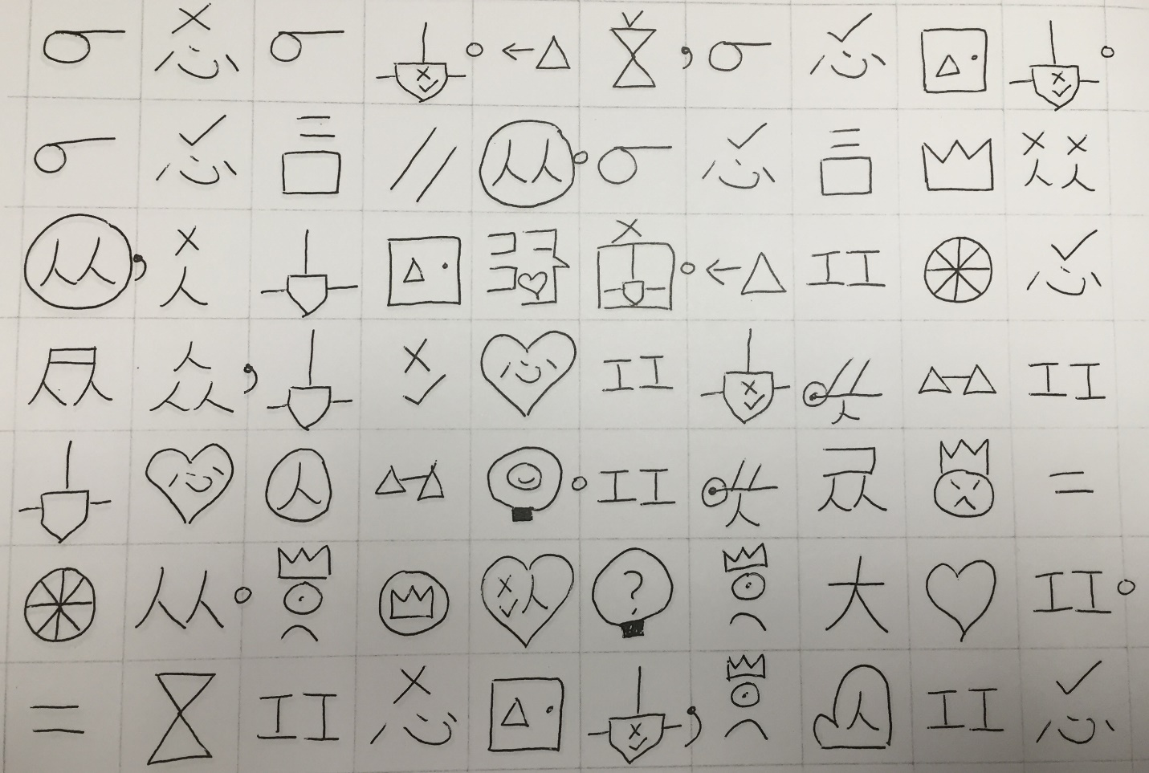

*Example of a page of Scripture in SUN.*

Part 2 – Explanation of Characters and Extensions

SUN consists of two types of symbols: characters and extensions. Characters are symbols that are the basic building blocks for other symbols. Characters can stand alone, but they can also be combined or altered to form new symbols. Characters are indicated in red in the Reader’s Dictionary as well as the Character Cards. Characters are taught using illustrations to assist recognition and memorization. To effectively use SUN, it is advised to commit all the characters to memory as soon as possible.

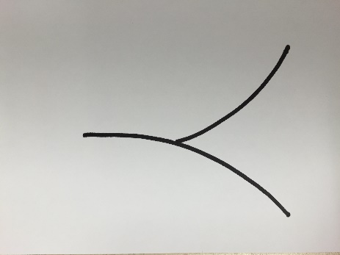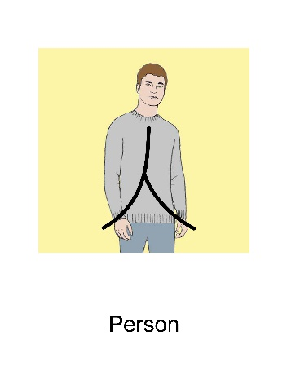

*On the left is the character for person. On the right is the illustration that is used to teach the character.*

Extensions are words that are formed by either combining or altering characters. There are three different types of extensions: combinations, alterations and proper nouns. Combinations are formed by combining two or more characters. Alterations are formed by changing a character or adding something to a character. Proper Nouns are combinations that are assigned to a name. Learning extensions rely more heavily on association rather than rote memorization. Extensions are indicated in green in both the Reader’s Dictionary and Extension cards.

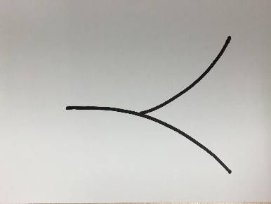 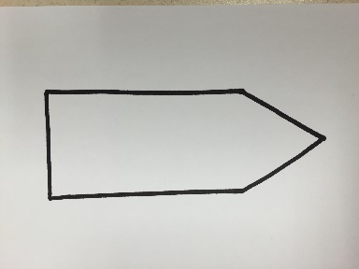 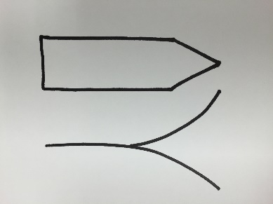

*Example of a combination: Combining the character person (left) and write (middle) makes writer (right).*

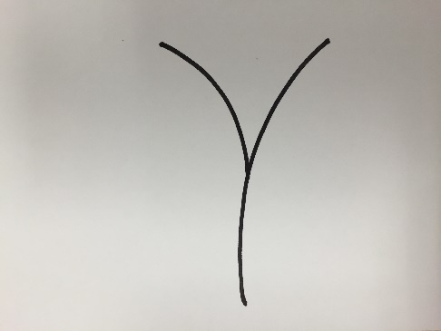 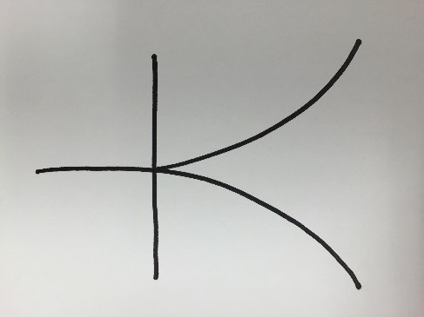

*Sleep Big*

The symbols “sleep” and “big” shown above are examples of alterations. In the word “sleep,” the character “person” is lying down on its side just as a person would be lying down when sleeping. In the word “big,” a straight line indicating arms stretched out is added to the character “person.” When a person stretches his arms out wide, he is often describing something big.

**Proper Nouns**

Proper nouns are indicated by assigning a symbol based on either the meaning of a name, or something significant about that person or place. Once the symbol is assigned, it is then placed inside the symbol for the common noun. Here’s an example.

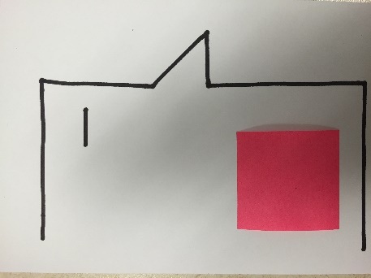

This word is man. There is pink box on the man’s cheek. If I come across the name of a man, like “Paul,” I would choose a symbol to put in the pink box based on either the meaning of the name or something significant in the person’s life. The name “Paul” means “little,” so I would use the character “small” and put it in that pink area. So the name Paul would look like this:

Here are some other types of proper nouns: (Note the pink area is where the symbol for each specific proper noun would be.)

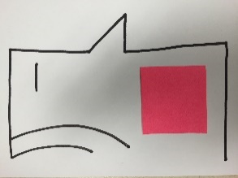 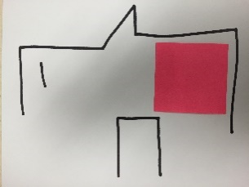 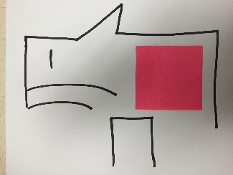 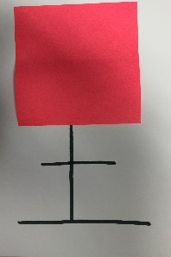 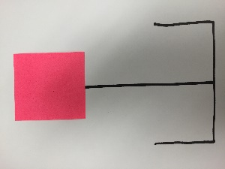

Woman Boy Girl Land (City, Country) Mountain

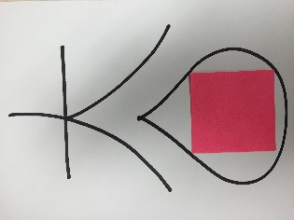 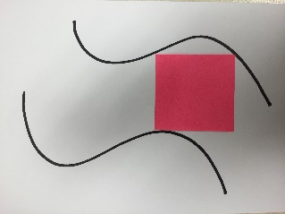

Sea River

In the translated text, proper nouns are indicated in blue.

In addition to character and extension cards, there are also yellow punctuation cards that explain the different types of punctuation used in SUN text. If the SUN text is printed on paper that has boxes or grids, the punctuation is placed on the vertical lines instead of in their own box. Quotation marks are printed at the top left and right corners of the box.

Part 3 – How to Teach Characters and Extensions.

**Teaching Characters**

**Step 1:** Take a Character Card. Show the student the side with the illustration for the character.

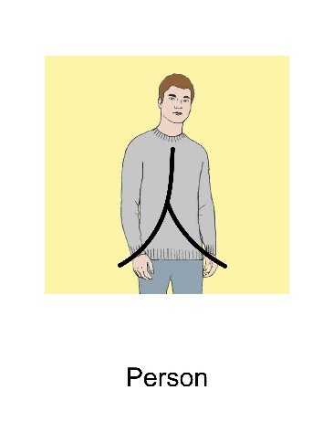

**Step 2:** Sign to the student what the character is. If more than one word is represented by the character, sign all the words.

**Step 3:** Trace the character with your fingers.

**Step 4:** Have the student trace the character with his fingers and sign the character. If more than one word is represented by the character, make sure the student signs all the words.

**Step 5:** Turn the teaching card over to the side without the illustration and repeat steps 2-4.

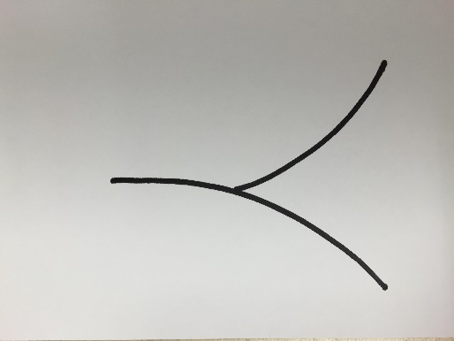

**Step 6:** After introducing 5 new characters, review by showing the student the side without the illustration and have the student sign the character to you.

**Step 7:** If the student forgets the character or makes a mistake, DO NOT sign the character. Flip the card over to the illustrated side and see if the student can remember or self-correct. (If the student cannot remember or self-correct even after seeing the illustration, repeat steps 2-4.)

**Teaching Extensions**

**Step 1:** If the extension is a combination, make sure you have taught all the characters in the combination. For example, before teaching the word “writer,” make sure the student knows the characters “person” and “write.”

**Step 2:** Show the student the extension card.

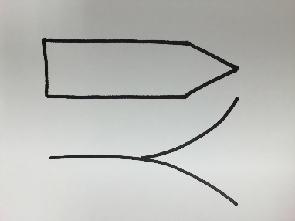

**Step 3:** Sign the word to the student. If more than one word is represented by the extension, sign all the words.

**Step 4:** Have the student sign the word to you. If more than one word is represented by the extension, make sure he signs all the words.

**Step 5:** Explain each extension using the explanation on the back of each extension card. Check for understanding.

**Step 6:** Have the student copy the extension in his own handwriting. After he writes the extension, have him sign the word or words for that extension.

**Step 7:** After each 5 extensions, review by showing the extension card and having the student sign the word or words.

**Step 8:** Review the same 5 extensions again, except this time have the student write the extension from memory.

Part 4 – Grammar

**Filler Words**

A symbol-based writing system naturally takes up more room than regular words. For this reason, it is important to try to use the fewest number of symbols to convey a thought so that it doesn’t take up too much space. That is why some “filler words” such as prepositions, articles and conjunctions and certain adjectives are left out. Certainly, there are times when such words are necessary to convey the correct meaning. In those cases, the filler words are included. However, wherever possible, the filler words are left out and the reader is expected to fill them in when he reads the passage.

Here is an example:

A sentence in English may sound like this: ***I walked to the store to buy some bread.***

Here is what the sentence would look like in SUN:

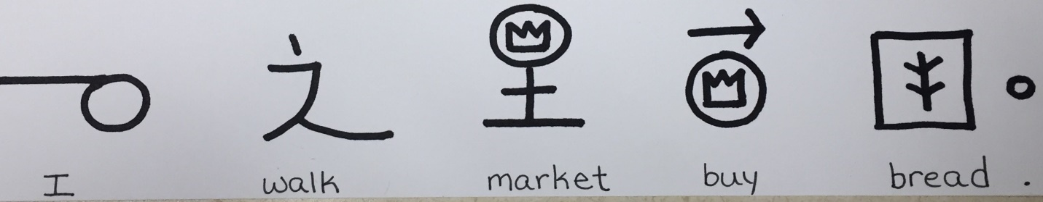

Notice the words that were left out in the sentence: (They are shown in red)

***I walked to the store to buy some bread.***

As the reader, the sentence still conveys the appropriate meaning even though the filler words are left out.

Here’s an example of times when filler words are not left out because they affect the meaning of the sentence. Look at the following sentences.

***I walked from the store to the house.***

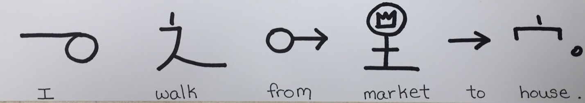

***I walked to the store and then to the house.***

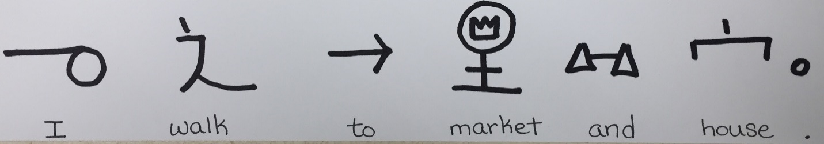

The words that are in red this time are included in the sentence because it makes a difference in the meaning. The first sentence suggests that I am starting at the store. The second sentence indicates that I went to both places. My starting point is not mentioned, but I definitely didn’t start at the store if I walked to the store.

**Pronouns**

There are no specific characters for pronouns such as “he,” “him,” “his,” “her,” “she,” “hers,” are not used. Instead, the name of the person (or the symbol for man, woman, or person) is repeated depending on the context of the sentence. This is to reduce the number of symbols each student must learn.

**Verb Tenses**

For the sake of simplicity, verb tenses are not used. In most cases, the context will dictate the tense of the verb, or there will be words in the sentence that will show what tense the verb is in.

Here’s an example: ***When I was small, I didn’t know how to walk.***

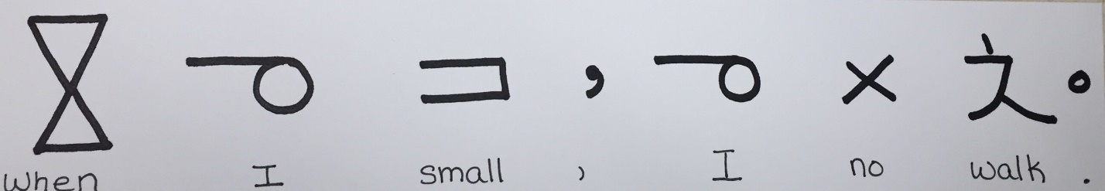

As you see, there are a lot of words left out including the past tense of the verb “do.” However, the reader can fill in the missing words just like we fill in missing words when children (or people learning our language) talk to us.

**Possessives**

Possessives are shown with a dot above the noun that is a possessive. The character that comes after the possessive belongs to the possessive. Here’s are a couple examples:

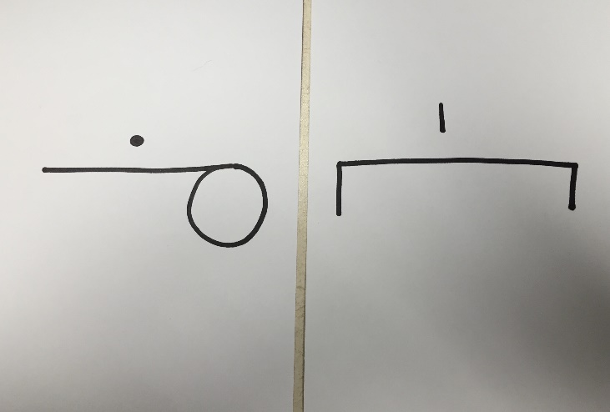

This is the phrase “my house.” The first symbol without the dot is “I” or “me.” Since it has a dot on it, that indicates a possessive noun, so the word becomes “my.” The word following the possessive is “house.” So the house belongs to me. It is “my house.”

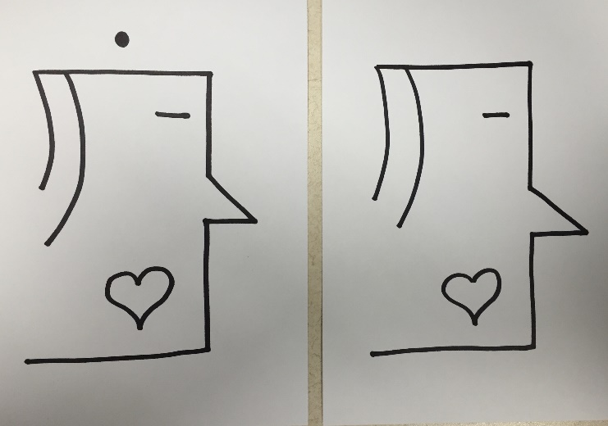

This is the phrase “Mother’s Mother” or “Grandmother.” To avoid creating another symbol for “grandmother,” the possessive noun is used. The second symbol belongs to the possessive noun that comes before it, so it is “mother’s mother.” If you are translating this and you say, “grandmother,” you would be correct.

Part 5 – Words with Multiple Meanings

The goal of SUN is that anyone can learn this system quickly and can get to Scripture as soon as possible. With that in mind, the fewer characters and extensions someone must learn, the better. That is why some words have multiple meanings. However, how does a reader decide which word to use? Here is where context plays a very important part in comprehension. Let’s try an example.

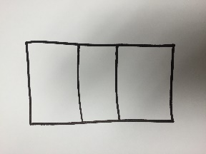

This is the word “eye.” It can also be the verb “see.” Now let’s look at the following sentence:

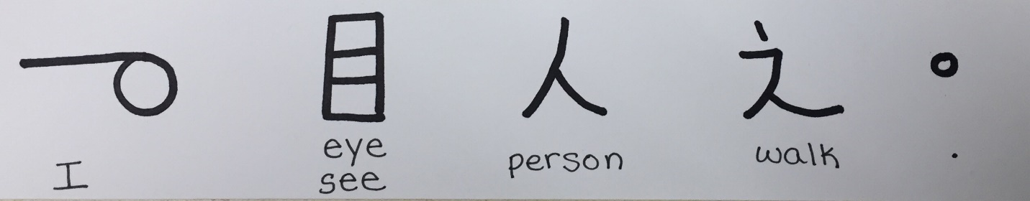

“I eye person walking” doesn’t make sense, but “I see a person walking” does. It is the reader’s responsibility to look at the context and pick the right word.

Part 6 – Changing a Symbol

Symbols may not be changed. This is to protect against confusion and delays that are caused by different opinions as to what the symbols should be. For example, what looks like house to me may not look like a house to someone else. If I want a house to be drawn a certain way, and someone else disagrees, we will waste a lot of time deciding what the symbols should be and never get to the important part of translating Scripture.

If you come across a word that is not in your language, find the closest word in your language and change the meaning, not the symbol. Here’s an example:

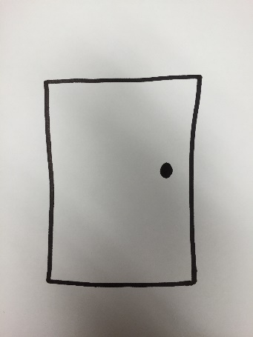

This is the symbol for door. Let’s pretend you don’t have doors where you live. You will then follow these steps to change the meaning.

1. Find out what the meaning of a door is – “A moveable solid barrier that opens or closes an entryway to a building.”
2. But then you think, “Our buildings don’t have a moveable solid barrier in the entryway, we only have an opening that serves as the entrance to the building.”
3. You may then decide that “entrance” is a better word than “door.”
4. In the dictionary, you will change **the meaning** of this symbol from “door” to “entrance.” You are not changing the symbol. You’re just changing the meaning of the symbol. That may mean that this symbol will require more effort to memorize than other symbols, but it will save the confusion of changing symbols.

Part 7 – Using the Dictionary

The Reader’s Dictionary is a way to look up symbols that you or your student may not be familiar with. The dictionary is divided into sections with each section consisting of one character and the extensions that come from that character. To find a symbol, follow these steps:

Step 1: Is the symbol a character or extension?

Step 2a: If it is a character, look at the table of contents page (the very first page) and find your symbol. If the character is not listed in the table of contents, that means that the character has no extensions. In that case it will be listed under the “Other Characters” section.

Step 2b: If your character is an extension, look for the main character in the extension. Generally speaking, the main character is either the **character** **at the top** or the **biggest character**. Here are some examples.

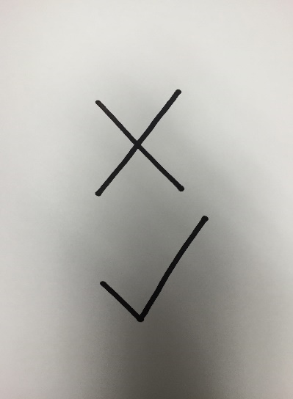

This is the word “bad.” It is an extension using the characters “no,” (x) and “good” (check mark). Since the “x” is on the top, you would look under the no section for this symbol.

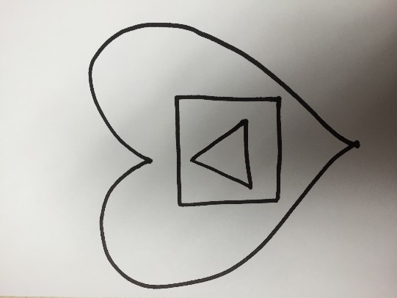This is the symbol for “hungry.” It is an extension using the characters “love,” (heart) “mouth,” (square) and “thing” (triangle). Since the heart is the biggest character, you would look under the love section for this symbol.

If you can’t find an extension under the character you think it should be listed, try looking under the other characters in the extension.

Numbers have their own section. To find the symbol for a number, look under the number section.

Symbols that have arrows in the top or biggest part are listed in the arrows section.

If the symbol is in blue, it is a proper noun. Look in the proper nouns section for the word.

Part 8 – Error Correction Process

When the student signs the sentence back to you, if you think there are errors in his translation, follow these steps to correct the error.

Step 1: Your first goal is to understand the error that is being made (if there even is an error). So make sure you understand what the student is signing. If needed, ask the student to sign the sentence again.

Step 2: Next, read the sentence in the source text.

Step 3: Determine if the meaning in the source text is captured in the student’s translation.

Step 4a: If the answer to step 3 is yes, there is no error. Move on with the next sentence.

Step 4b: If the answer to step 3 is no, determine where the error is. Point to the symbol that caused the error, then sign the correct meaning for that symbol.

Step 5: Sign the correct translation of the symbols to him.

Step 6: Ask him to repeat the correct sentence back to you.

Part 9 – Capturing the Translation

You and your student may find that it is beneficial to capture the student’s translation on video so that the student can watch it in the way that the student communicates most naturally. Since SUN is like a second language, we want the Scriptures to be in the student’s “heart language,” (the language that he dreams in, prays in, and thinks in) so it may be more natural for the student to watch his signed translation on video when he’s “reading” it later. So here are the steps to capture it on video.

Step 1: Have the student practice the sentence correctly a couple times.

Step 2: Use a cell phone (or other video recording device) to record the translation.

Step 3: Check the translation against the source text for accuracy.